Phase II: Database Design & Implementation

# System Proposal

## Detailed Description

For our project we are creating a database to track pitching stats in baseball games. The database consists of four Tables, GAME, PLAYER, INNING, and PLAY. For every pitch, we add a row will to the PLAY table storing the following information: pitcher, game, inning, pitch Type (ex. Fastball, Curveball, Slider, Cutter, Change Up, Splitter), pitch count (0-1, 2-1, etc.) the result of the play (strike, foul, ball, hit, etc.), and the speed of the pitch. The player table holds a unique player ID, the first and last name of the player, the player’s jersey number, and their total games played. We also store inning data: the game ID, inning number, player that is pitching, number of outs, and the total number of pitches that inning. Lastly for each game we store a game ID, name of the opposing team, date of the game, and cumulative pitches for the game. With every new pitch added to the database, triggers will maintain the outs stored in innings based on the pitch count, number of pitches for the inning and the game, games played for each pitcher, and outs increased based on strikeouts. Users will be able to dissect data in several ways. We plan to supply a view for each game with the following statistics

* strikes per pitch type (hit, strike, foul, ball)
* balls per pitch type
* speed per pitch type
* percentage of pitches resulting in ball
* percentage of pitches resulting in strike
* percentage of pitches resulting in hit
* Counts of each pitch type
* Pitches per out
* Number of pitches thrown

Next for each pitcher we plan to create a view with the following information

* strikes per pitch type (hit, strike, foul, ball)
* balls per pitch type
* speed per pitch type
* percentage of pitches resulting in ball
* percentage of pitches resulting in strike
* percentage of pitches resulting in hit
* Counts of each pitch type
* Number of pitches thrown

And lastly for each inning we want a view of the following information

* Number of pitches thrown
* strikes per pitch type (hit, strike, foul, ball)
* balls per pitch type
* speed per pitch type
* percentage of pitches resulting in ball
* percentage of pitches resulting in strike
* percentage of pitches resulting in hit
* Counts of each pitch type

## Table

|  |  |  |  |
| --- | --- | --- | --- |
| Proposed Functionality | Member | Description | Code |
| View: strikes per pitch Type per game, pitcher | John | The view allows users to compare how often each type of pitch (e.g. fastball vs. curveball vs. splitter etc.) results in a strike. |  |
| View: balls per pitch Type per game, pitcher | John | The view allows users to compare how often each type of pitch (e.g. fastball vs. curveball vs. splitter etc.) results in a ball. |  |
| View: speed per pitch Type per game, pitcher | John | The view shows the average speed for each pitch type sorted by each game or each pitcher |  |
| View: percentage of pitches resulting in ball per game, pitcher | John | The view shows the percentage of all pitches that result in a ball for the game or the pitcher |  |
| View: percentage of pitches resulting in strike per game, pitcher | Jack | This view shows the percentage of all pitches that resulted in a strike for the game or the pitcher |  |
| View: percentage of pitches resulting in hit per game, pitcher | Jack | This view shows the percentage of all pitches that result in a hit for the game or the pitcher |  |
| View: Counts of each pitch type per game, pitcher | Jack | This view shows the count of each pitch type for a game or a pitcher |  |
| View: Number of pitches thrown per game, pitcher | Jack | This view shows the number of total pitches thrown for a game or a pitcher |  |
| Function: strikes per pitch Type per inning | Joe | This Function will add a strike to the type of pitch per inning |  |
| Function: balls per pitch Type per inning | Joe | This function will add a ball to the type of pitch per inning |  |
| Function: speed per pitch Type per inning | Joe | This function adds the speed of the pitch to the type of pitch per inning | Inserting image... |
| Function: percentage of pitches resulting in ball per inning | Joe | This function gets the percentage of the pitches resulting in ball per inning |  |
| Procedure: percentage of pitches resulting in strike per inning | Patrick | This procedure will take in the inning and game id, count the total pitches and total strikes and calculate the strike percentage |  |
| Procedure: percentage of pitches resulting in hit per inning | Patrick | This procedure will take in the inning and game id, count the total pitches and total hits and calculate the hit percentage |  |
| Procedure: Counts of each pitch type per inning | Patrick | This procedure will take in the inning, game id, and pitch type and count the number of pitches for that pitch type |  |
| Procedure: Number of pitches thrown per inning | Patrick | This procedure will take in the inning and game id and count number of pitches |  |
| Trigger that adds +1 to pitch count of game and inning after pitch | Cameron | Trigger that updates numPitches = numPitches++ in inning and game after a pitch is thrown |  |
| Trigger that subtracts -1 to pitch count of inning after pitch its deleted | Cameron | Trigger that updates numPitches = numPitches-- in inning and game after a pitch is delete. This would be used in instances where the pitch button was accidentally hit on the UI. |  |
| Trigger that adds +1 to gamesPlayed on Pitcher after they pitch once in an inning | Cameron | After a pitcher goes in for their first inning in a game, their gamesPlayed stat increases by 1. The design also takes into effect if another pitcher were to come in on the same inning. |  |
| Trigger that adds +1 to out count after 3 strikes | Cameron | If the pitchcount reaches 03, 13, 23, or 33, that means the pitcher struck out the batter. This trigger adds +1 to the out count in innings. |  |

# Conceptual Database Design

<https://github.com/CS-331/SJU-Baseball-DB/tree/master/ER>

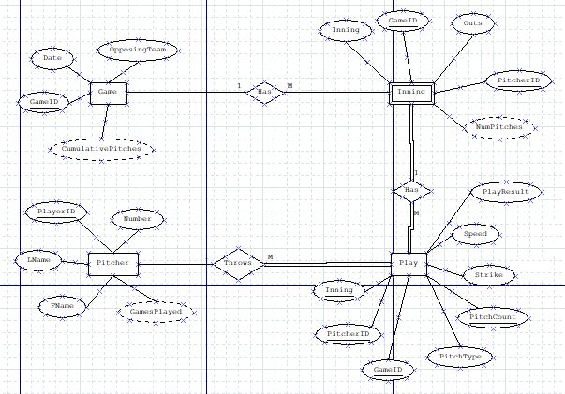

* Entity Types:
  + **Pitcher**(PlayerID, FName, LName, Number, GamesPlayed)
  + **Game** (GameID, OpposingTeam, Date, cumlativeNumPitches)
  + **Inning** (GameID, Inning, Outs, top/bottom/complete, NumOfPitchesInning)
  + **Play** (GameID, PitchCount, PitcherID, Inning, PitchType, StrikeY/N, Speed,)

# Logical Database Design

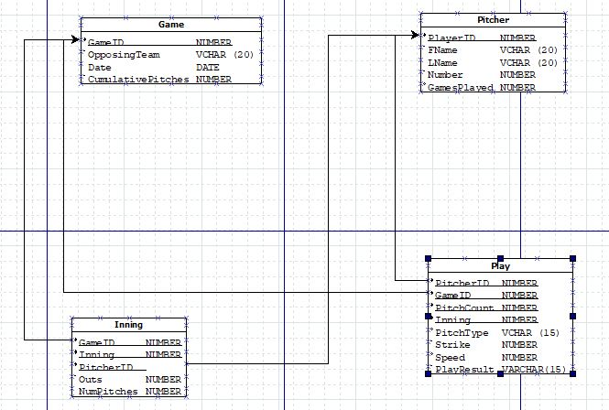

# Physical Database Design

CREATE TABLE Game (

GameID NUMBER NOT NULL

OpposingTeam VARCHAR(20)

GameDate DATE,

cumlativePitches NUMBER

PRIMARY KEY(gameID)

);

CREATE TABLE inning (

gameID NUMBER NOT NULL,

inningID NUMBER(2,0) NOT NULL CHECK(inningID >= 0),

PlayerID NUMBER NOT NULL,

outs NUMBER(1,0) CHECK(outs >= 0),

status NUMBER,

numPitches NUMBER

PRIMARY KEY(gameID, inningID, PlayerID)

);

CREATE TABLE pitcher (

playerID NUMBER NOT NULL,

fName VARCHAR(20),

lName VARCHAR(20),

playerNumber NUMBER(3,0) CHECK(playerNumber >= 0),

gamesPlayed NUMBER

PRIMARY KEY(playerID)

);

**PlayResult = Hit, Foul Ball, Looking, Swinging

CREATE TABLE play (

pitcherID NUMBER NOT NULL,

gameID NUMBER NOT NULL,

inningID NUMBER(2,0) NOT NULL CHECK(inningID >= 0),

pitchType VARCHAR(15) NOT NULL,

strike NUMBER(1,0) CHECK(strike >= 0),

speed NUMBER CHECK(speed >= 0),

pitchCount NUMBER(5,0),

playResult VARCHAR(15),

PRIMARY KEY(pitcherID, gameID, pitchCount, inningID)

);

ALTER TABLE inning

ADD CONSTRAINT fk_game_inning

FOREIGN KEY (gameID) REFERENCES game(gameID) ON DELETE CASCADE;

ADD CONSTRAINT fk_pitcher_inning

FOREIGN KEY (PlayerID) REFERENECES pitcher(playerID) ON DELETE CASCADE;

/* add play foreign key pitcher */

ALTER TABLE play

ADD CONSTRAINT fk_play_pitcher

FOREIGN KEY (pitcherID) REFERENCES pitcher(playerID) ON DELETE CASCADE;

/* add play foreign key (game, inningID) */

ALTER TABLE play

ADD CONSTRAINT fk_play_inning

FOREIGN KEY (gameID, inningID) REFERENCES inning(gameID, inningID) ON DELETE CASCADE;

# **SQL Routines**

**Trigger 1 – AutoUpPitchCount (Cameron)**

**Description:** A trigger that increases the numPitches in inning and cumulativePitches in inning by 1 every time the pitcher throws.

**Code:**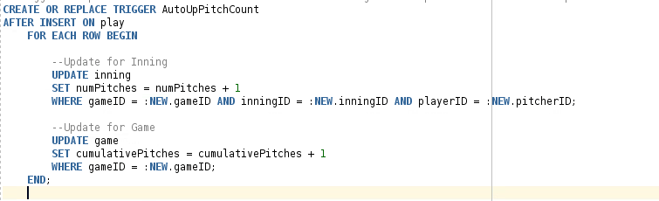

**Test:**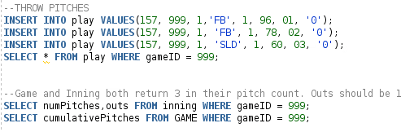

**Output:**

Inning: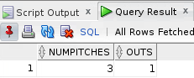 Game: 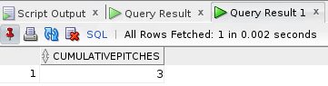

**Trigger 2 – AutoDownOnDeletePitch (Cameron)**

**Description:** Trigger that updates numPitches = numPitches-- in inning and game after a pitch is deleted. This would be used in instances where the pitch button was accidentally hit on the UI.

**Code:**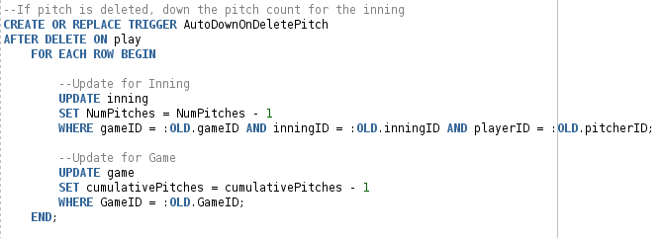

**Test:**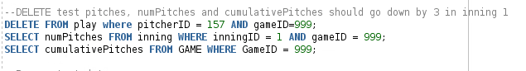

**Output:**

Inning: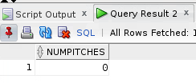Game: 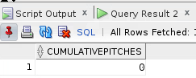

**Trigger 3 - UpGamesPlayed (Cameron)**

**Description:** After a pitcher goes in for their first inning in a game, their gamesPlayed stat increases by 1. The design also takes into effect if another pitcher were to come in on the same inning.

**Code:**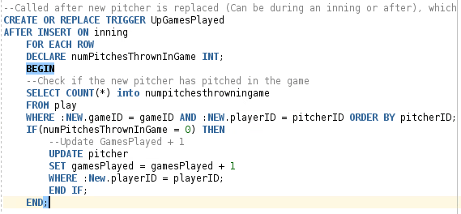

**Test 1:**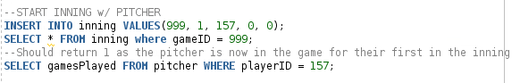

**Output:**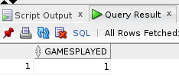

**Test 2:**



**Output:**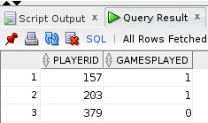

**Trigger 4 – UpOutsOnPitchCount (Cameron)**

**Description:** If the pitchcount reaches 03, 13, 23, or 33, that means the pitcher struck out the batter. This trigger adds +1 to the out count in innings.

**Code:**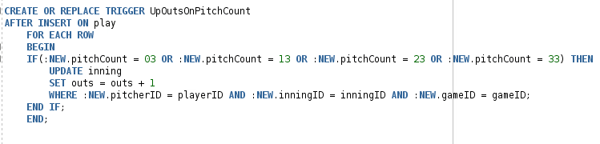

**Test:**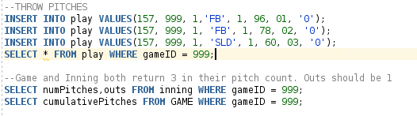

**Output:**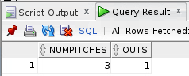

**Data Used in Procedure Test Calls**

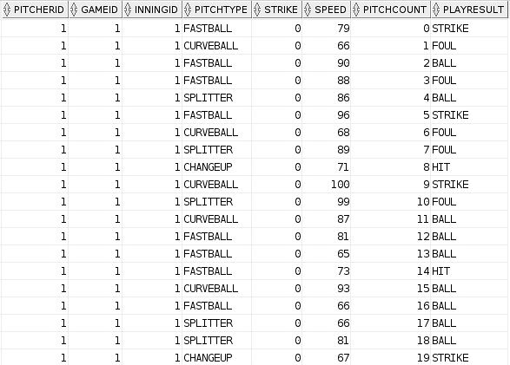

**Procedure 1 - Percentage of pitches resulting in strike per inning**

**Code & Test**

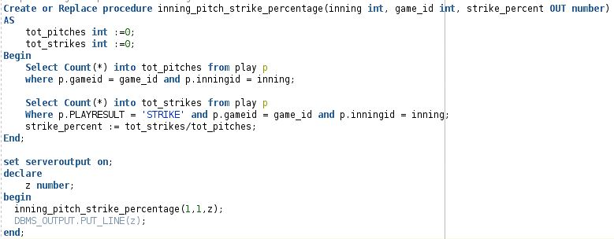

**Output**

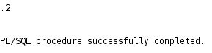

**Procedure 2 - Percentage of pitches resulting in hit per inning**

**Code & Test**

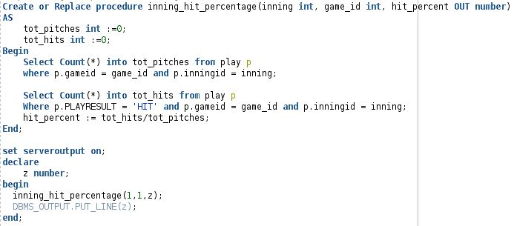

**Output**

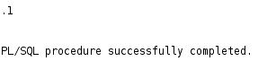

**Procedure 3 - Percentage of pitches resulting in hit per inning**

**Code & Test**

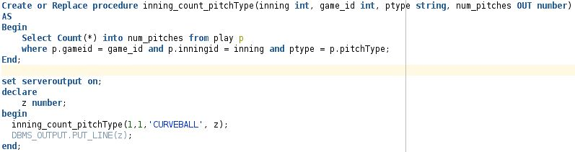

**Output**

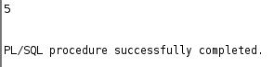

**Procedure 4 - Number of pitches thrown per inning**

**Code & Test**

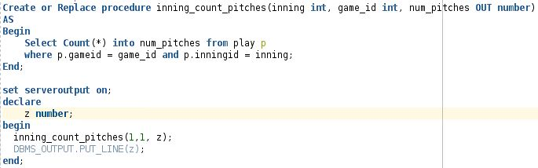

**Output**

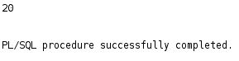

**DATA USED IN NEXT 4 VIEWS (JACK)**

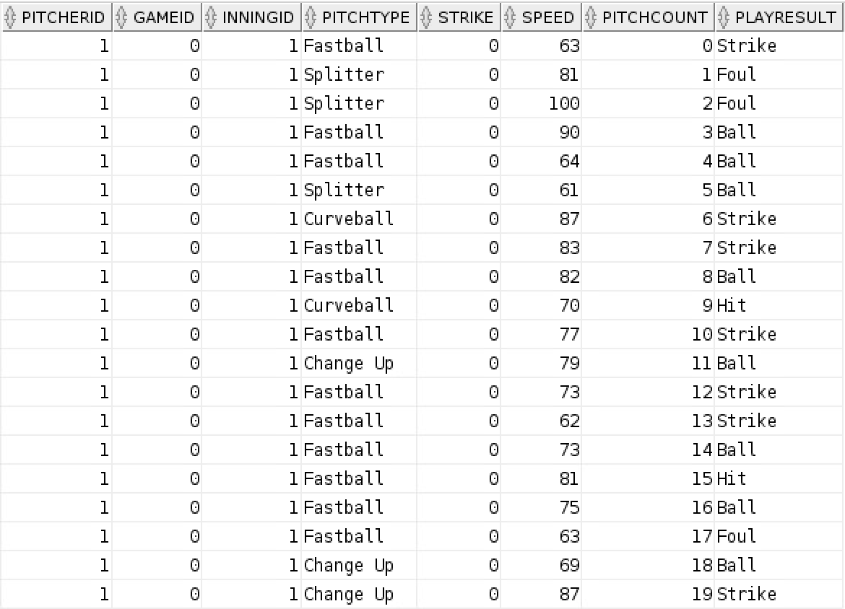

**View – Strike Percentage per Game (Jack)**

**Code & Test:**

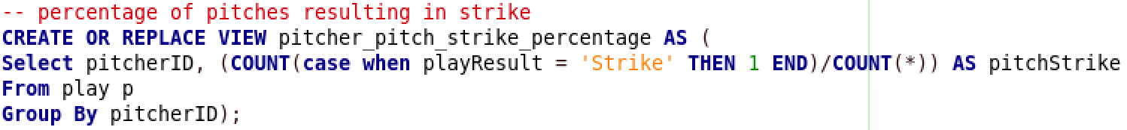

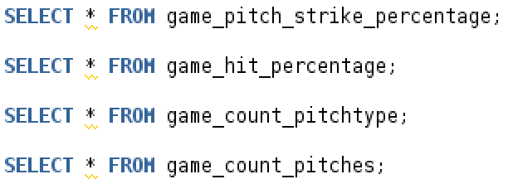

**Output:**

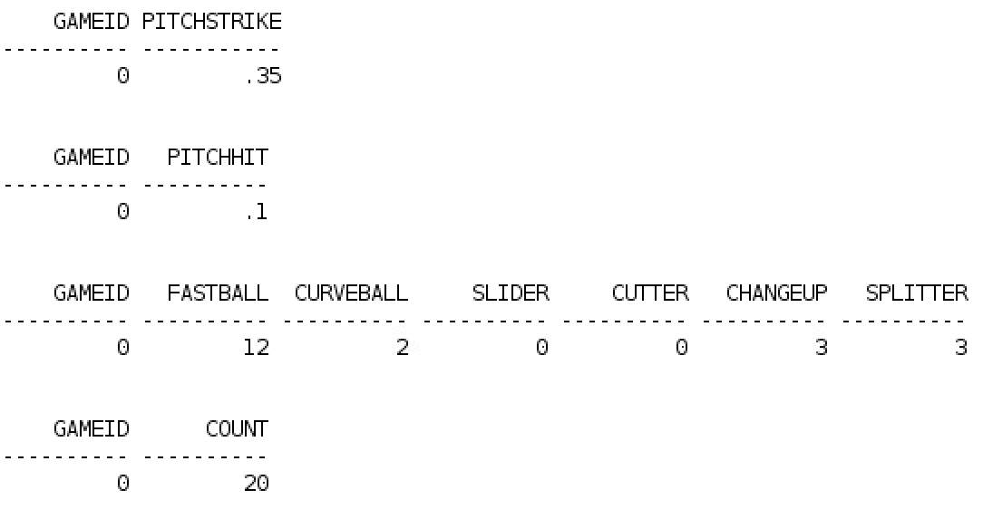

**View – Hit Percentage per Game (Jack)**

**Code & Test:**

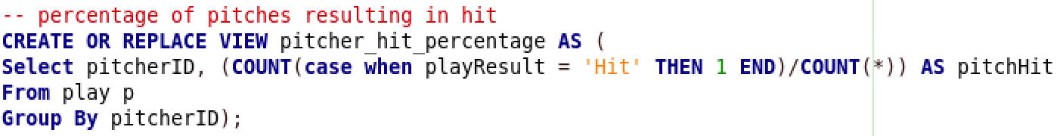



**Output:**



**View – Pitch Type Count per Game (Jack)**

**Code & Test:**

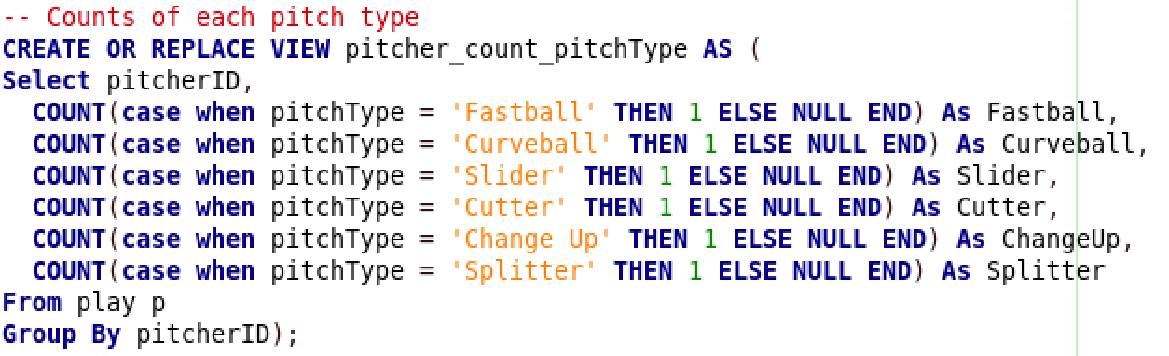



**Output:**



**View – Total Pitch Count per Game (Jack)**

**Code & Test:**

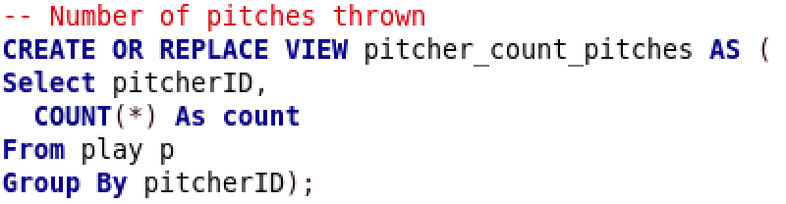



**Output:**



**View – Strikes per Pitch Type per Game (John)**

**Test:**

**Output: **

**View – Balls per Pitch Type per Game (John)**

**Test:**

**Output:**



**View – Speed per Pitch Type per Game (John)**

**Test:**

**Output: **

**View – Percentage of Pitches Resulting in Ball per Game (John)**

**Test:**

**Output:**

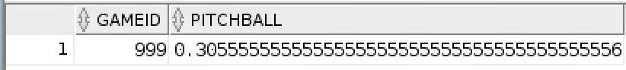

**DATA USED:**

# **Data Processing**

**Query 1:**

**Description**: For each game, get the total percentages of strikes, balls, and hits on pitchers so that the games can be compared based on their outcome.

**Code:**



**Output:**

**Query 2**

**Description:** For each pitcher, get their ball and strike percentage per inning

**Code:**

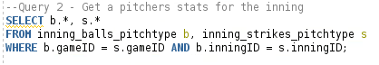

**Output:**



**Query 3**

**Description:** for every game, get the inning had the highest ball percentage

**Code:**

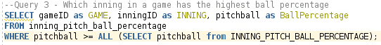

**Output:**



Get the pitchtype that is the best for a specific pitcher

**Table for queries 4-7**



**Query 4**

**Description:** Get the game with the most strikes for fastballs

**Code:**

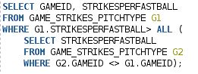

**Output:**

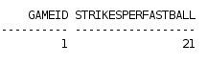

**Query 5**

**Description:** Get the game with the most strikes for curveballs

**Code:**

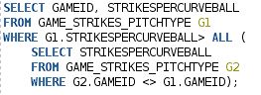

**Output:**



**Query 6**

**Description:** Get the game with the most strikes for change ups

**Code:**

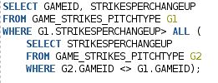

**Output:**



**Query 7**

**Description:** Get the game with the most strikes for splitters

**Code:**

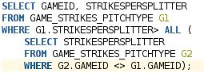

**Output:**

